

MATES Computer Science

**Senior Capstone Project Bi-Weekly Progress Report**

| Project Title | Journal Time! |
| --- | --- |
| Team Members | Shayne Lada, Ava McNabb, Lauren McNaboe |
| Dates Covered by Report | 2/26/24 - 3/8/24 |
| Link to Github | <https://github.com/code-shayne/journal-time-/tree/main> |

# **Summary of Project**

Journal Time! is a web app that allows users to journal and store entries online. The web app would provide prompts or free-journaling options and save all entries to unique user accounts. Users can also track emotions by indicating what they are feeling at the time of journaling. After each entry the user will receive a certain number of points or currency, incentivising journaling. The points can be used to buy accessories within the website such as different prompt packages, website themes, or journaling pets. The journaling pets would be avatars that live on the interface and encourage the user to journal and provide motivational messages. Points could also be used to customize and feed/play with pets. Users can track their journaling progress and view graphs and summaries of their emotions in a separate space on the web app. Email notifications can be scheduled to remind the user to journal or sent if the account hasn’t been used for 2 weeks. This project will encourage journaling, which is a useful practice for mental health and wellbeing. It will also make the process more accessible and fun for the users.

1. Summary of Progress this Period

We added details to the entries page that, when connected to a database, should be able to retrieve past entries from the user when signed in. In the store, we created a system for making purchases, a filter button, and a sort button. These will all have functionality soon. On the login page, a login and signup popup were created to help users enter their account or create a new one. The issue is that you can’t access the signup section of the login page. Once again, when this is hooked up to a database, users should be able to add themselves to the table or check if they are already registered. A new about page was made that describes who we are!

# **Detailed Progress this Period, separated by Team Member**

Lauren - created two login pages which accept username and password

* One of the pages shows username and password in the url (bad) BUT you can input things
* 
  + This one needs to have a registration page, but at least you know it accepts something and it goes somewhere
  + If we use this one, I need to a) make it look nicer and b) need to figure out how to not show usernames and passwords in the url
  + 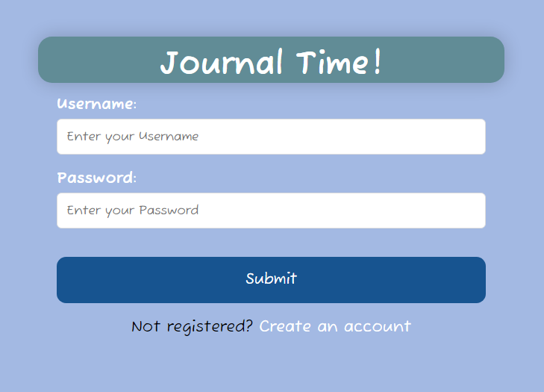
* In the other one, you can put things in, but it doesn’t do anything (even though it did last week)
  + has registration tab that, once again, worked last week but now doesn’t
  + gives three tries to enter information before locking you out
  + NEW PROBLEM: when i add “username” and “password” above the box, the login button moves over…
  + 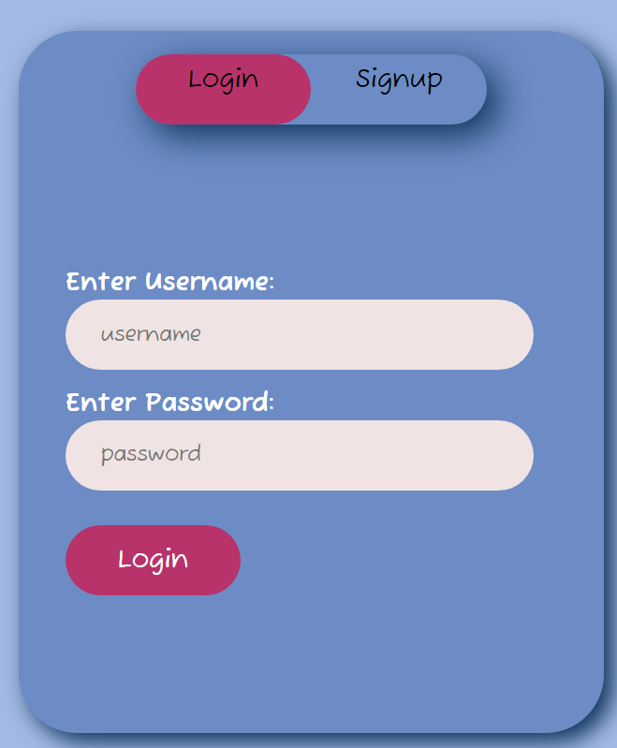
* worked on JavaScript stuff a little
  + mainly functions for login and signup buttons
  + idk I mainly googled this stuff I don’t know JavaScript
* also worked on making a SQL database (nightmarish)
  + wrote the code for creating a table and entering user data BUT…
  + I still need to actually set up the database on MySQL, and I don’t have access to that here
    - If I set it up at home, I should be able to link into it with MSSQL extension but we shall see

Shayne -

* created HTML and CSS files for the entries, store, and about pages
* designed elements for each in Adobe XD and implemented them in the code
  + Entries page: side panel for filtering past entries by different factors and a search bar for keywords; list of entries (only placeholders for now) and an option to add a new entry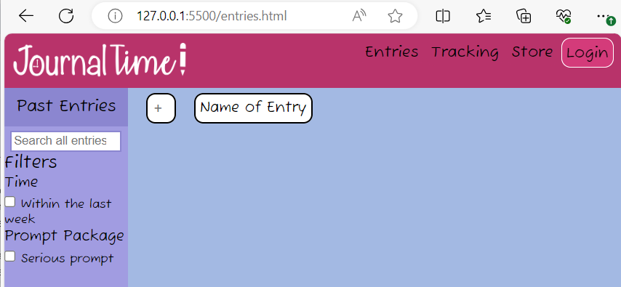
  + Store page: top section that can be used to search available items, filter them, or sort them; area that shows current balance of currency (crystals) received from journaling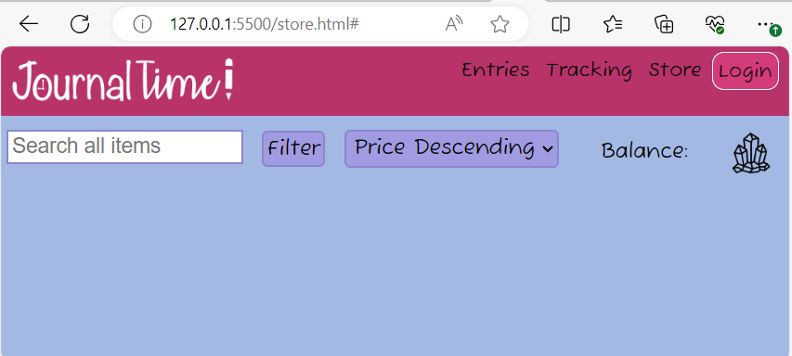
  + 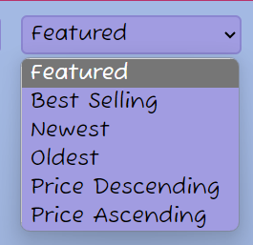The sort function is a drop down that can be changed by the user
  + 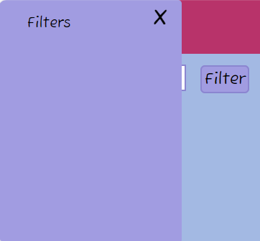The filter function is a popup where users can select which filters they want to apply
  + About page: description of the project and its initiative; an area where users can find places to contact the ‘company’ via (fake) email.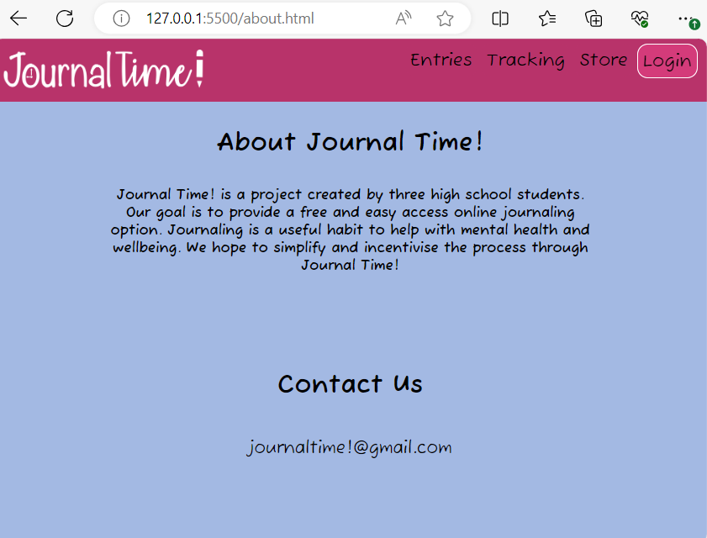
  + created a footer for the webpage where the about and contact information is linked to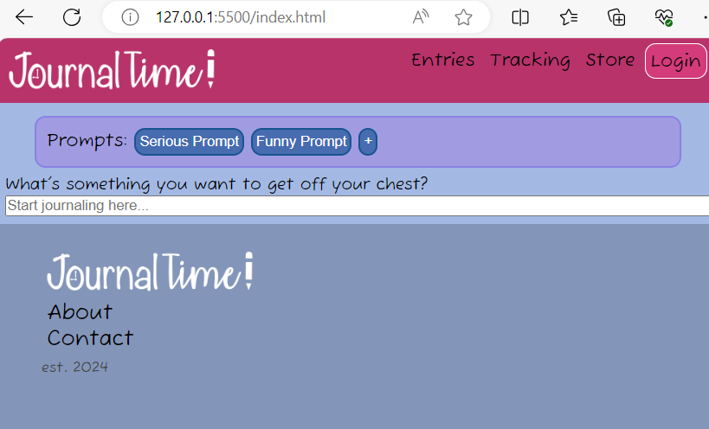

Ava -

Tutorials -

* Continued JavaScript course on Codecademy, and progressed through loops, iterators, etc. I learned basic syntax and methods in Javascript, and worked on defining functions (which is mainly the use in our project).

link: <https://www.codecademy.com/enrolled/courses/introduction-to-javascript>

* I also continued taking relevant lessons in the Back-End Engineer path on Codecademy. Within this path, I took multiple lessons to learn HTML and began with CSS. I jump around in this one a lot, because the relevant information is somewhat scattered with other lessons.

link: <https://www.codecademy.com/enrolled/paths/back-end-engineer-career-path>

Code

* Worked on adding JavaScript functions to the HTML/CSS frontend
* Created test files with different functions to practice connecting to HTML
* Having some difficulty smoothly connecting JavaScript code to HTML efficiently

# **Difficulties Encountered this Progress Period**

Creating the login page was the biggest issue that I (Lauren) encountered this week. Making the interface was easy but the actual functions behind the login is what’s throwing me off. Hopefully in the next few weeks I can figure out how to make these buttons work and connect it to a database. The other login page I made accepts input, but it’s ugly.

# **Updated Trello Board and Discussion**

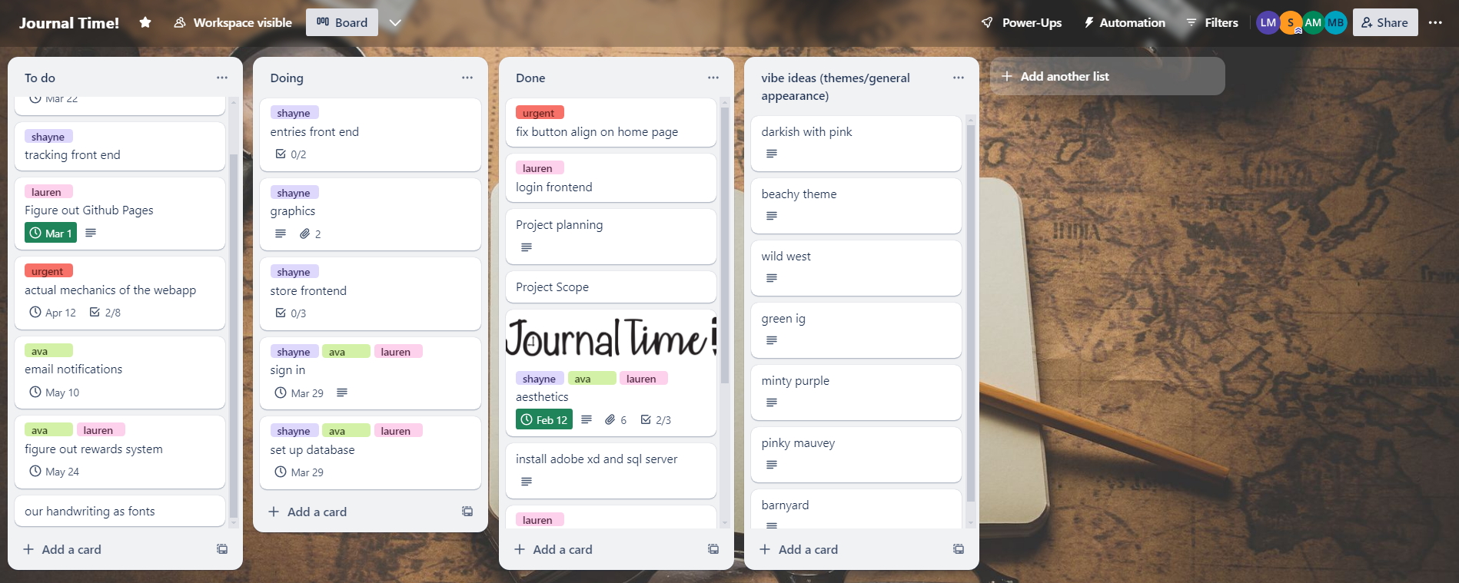

<https://trello.com/b/5P60HsFp>

More tasks were added and completed this sprint. A lot of the front end tasks were moved into the doing category and urgent bug fixes were completed.

# **Tasks to Be Worked on in Next Progress Period** **Lauren** -

* fix login page to be able to register an account
* set up SQL database and connect to user input
* encrypt database

Shayne -

* design the tracking page in Adobe XD and implement it with HTML and CSS
* update design of home page to account for more features
  + area to input emotions for tracking
  + bigger box to journal in
* create more filters on the entry and store pages and finalize design for how past entries and store items appear

Ava -

* implement more javascript functions into the HTML and CSS
* work on adding functionality to buttons and looking in to connecting database code to the front end

# **Additional Information**

After looking at online resources for backend stuff, we have decided JavaScript is probably the best route. We may still implement Python here and there, but JavaScript is better documented. We have successfully delegated tasks and have fallen into a rhythm with what we’re doing. Overall, everything is moving forward.